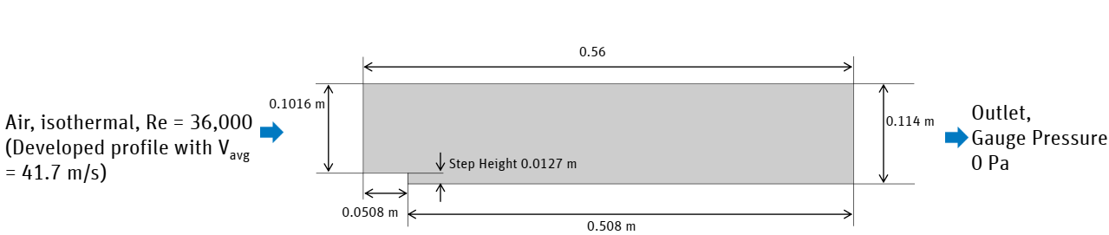

Prepare the mesh for following dimension
Step height and total length should be different for every students.
total length=.56 +last two digit of your admission no./10
For example if adm no. is 18SCME1050008 then total length= 0.56+8/10=
Step height =12.7 mm+last two digit of your admission no.
For example if adm no. is 18SCME1050008 then step height= 12.7+8mm

For the Flow over a backward facing step at Re = 36,000 perform simulation of steady incompressible turbulent flow. Step represents a fixed separation point and the goal is to predict the size of the separation zone and the shear stress on the wall downstream. Report separation length and picture of step showing boundary layer separation. Plot zoomed view of velocity vector and stream line just after the step

